NEWARK TOWN CENTRE SHOPWATCH
Launched in June 2006 as Pubwatchonline.co.uk and ShopwatchOnline.co.uk, Schemelink have successfully provided online scheme portals in the UK since and lead the way in online scheme data sharing and communication. Schemelink.co.uk is an evolution of the original services and has been developed as a central point for easier sharing of data & communication across scheme types, unifying online scheme services for members, police & councils. By bringing all these services to one central point strengthens and simplifies the task of managing schemes for Pubwatch and Shopwatch with the unified task of reducing crime and anti-social behaviour.
Feature rich and incorporating a range of different ways of communicating such as SMS & live chat, this service has proven itself to the 1000's of registered members as an invaluable tool for the day-to-day operations and management of a scheme.
Over the 10 years since our launch in 2006 Schemelink have learned in-depth how schemes and other agencies operate allowing them to develop the right solutions and functions to facilitate scheme operations. With Schemelink, functions are now modular in design allowing customisation of an online portal to deliver the functions that best suit user’s needs. This modular design allows you to manage many different types of schemes and share data across all or just some schemes if required.
Newark and Sherwood District Council and Nottinghamshire Police are working with Newark Town Centre Shopwatch to create better partnership working and try to reduce or prevent shop thefts and anti-social behaviour within or from your businesses. As part of this we have agreed to pay for active members (see below) to have access to the Schemelink app with features which include:
- Group chat – quick and effective way to make contact which is similar to WhatsApp.
- Incident logs, which once submitted are sent through to all members similar to a feed on Facebook
- Push notifications – these need to be activated to ensure you receive notifications as you would do for WhatsApp
- Ability to poll about a ban rather than wait until the next meeting
- Banned gallery – which includes a security check of individual watermarks for members. If images were shared inappropriately (either inside or outside of the system) it would be easy to discover who had shared them.
- Each member can appoint temporary access to others within their shop for a period of 1 month. This can be renewed as necessary.
An active member is a venue that is represented at a minimum of 75% of the Shopwatch meetings. Failure to attend will result in access to the app being removed. It is currently envisaged that there will be 6 Shopwatch meetings annually (details to be arranged).
*For those of you who currently hold a Shopwatch radio, this service will continue for those who wish to keep it, or those who wish to sign up to it and you will continue to be invoiced accordingly*

**Please note that although the local policing team will also be users on this app, there will still be a requirement for any incidents requiring police attention to be formally reported through the correct channels by telephoning 999 in emergency situations, 101 for non-emergencies or reporting online via https://www.nottinghamshire.police.uk/do-it-online/report-online
If you wish to sign up to this scheme, please complete the form below. Once we receive this completed form you will be sent a voucher via email to log on to the scheme. When you register you will be able to take an information tour around the system. It is very user friendly and self-explanatory, but help will be available if you have any difficulties.
To assist those of you who do suffer with any Anti-Social Behaviour near or within your premises, we will be asking all active members to sign up to the Neighbourhood Watch Community Safety Charter. We will undertake further promotion of this in the new year but for now if you would like to have a look at what it involves, please visit their website – it is free to join!
Community Safety Charter | Neighbourhood Watch Network (ourwatch.org.uk)

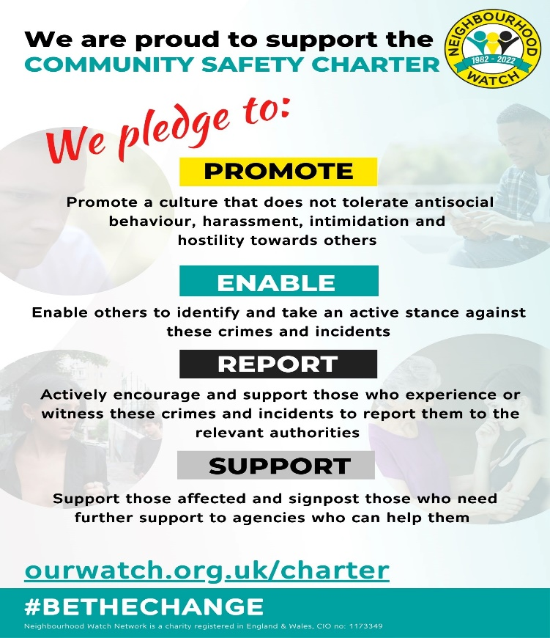

NEWARK TOWN CENTRE SHOPWATCH APPLICATION - Please read the following information carefully: -
I would like to apply to sign up to the Newark Town Centre Shopwatch Schemelink app. By signing and submitting this application I agree that I (and any staff who are given access to the app) will abide by all confidentiality requirements within the scheme. I am aware that any breach of this would result in immediate exclusion from the scheme and I (or my members of staff) may be subject to prosecution.
Information provided here will only be used by NSDC or Nottinghamshire Police for the purposes of administration of the scheme or the investigation, prevention and detection of crime. This information will only be retained whilst you are an active member of the scheme in line with our GDPR and DPA policies.

Signed

Name (in Capitals)
Date

Name of Business

Name of Owner/Manager

Address
(inc Postcode)

Mobile Number
Landline/Other Number
Email (personal/business)
Keyholder Details (if more than one keyholder please list)

CCTV at Property | Yes/No
Location of CCTV (please indicate whether inside or outside and how many?
Who has access to the CCTV?
How long is the CCTV kept for? (i.e does it overwrite every 14 or 28 days?)
Under what format are you able to release the CCTV to the police? (i.e can be emailed, memory stick, USB?)

When complete please return this form via email to Yvonne.Swinton@newark-sherwooddc.gov.uk
If you wish to return this form by post please address to: -
Yvonne Swinton
Community Protection Manager
Newark and Sherwood District Council
Castle House
Great North Road
Newark
NG24 1BY

