**COMMUNITY CHEST APPLICATION FORM**

Please refer to the guidance document when completing this form.

Please submit completed forms and supporting documents to

[getinvolved@newark-sherwooddc.gov.uk](mailto:getinvolved@newark-sherwooddc.gov.uk)

**Main Contact Details**

**Name of applicant:**

Click or tap here to enter text.

**Applicant email address:**

Click or tap here to enter text.

**Applicant phone number:**

Click or tap here to enter text.

**Applicants contact address - if no email:**

Click or tap here to enter text.

**Name of group or organisation if applicable:**

Click or tap here to enter text.

**Community Chest Grant amount requested £:**

Click or tap here to enter text.

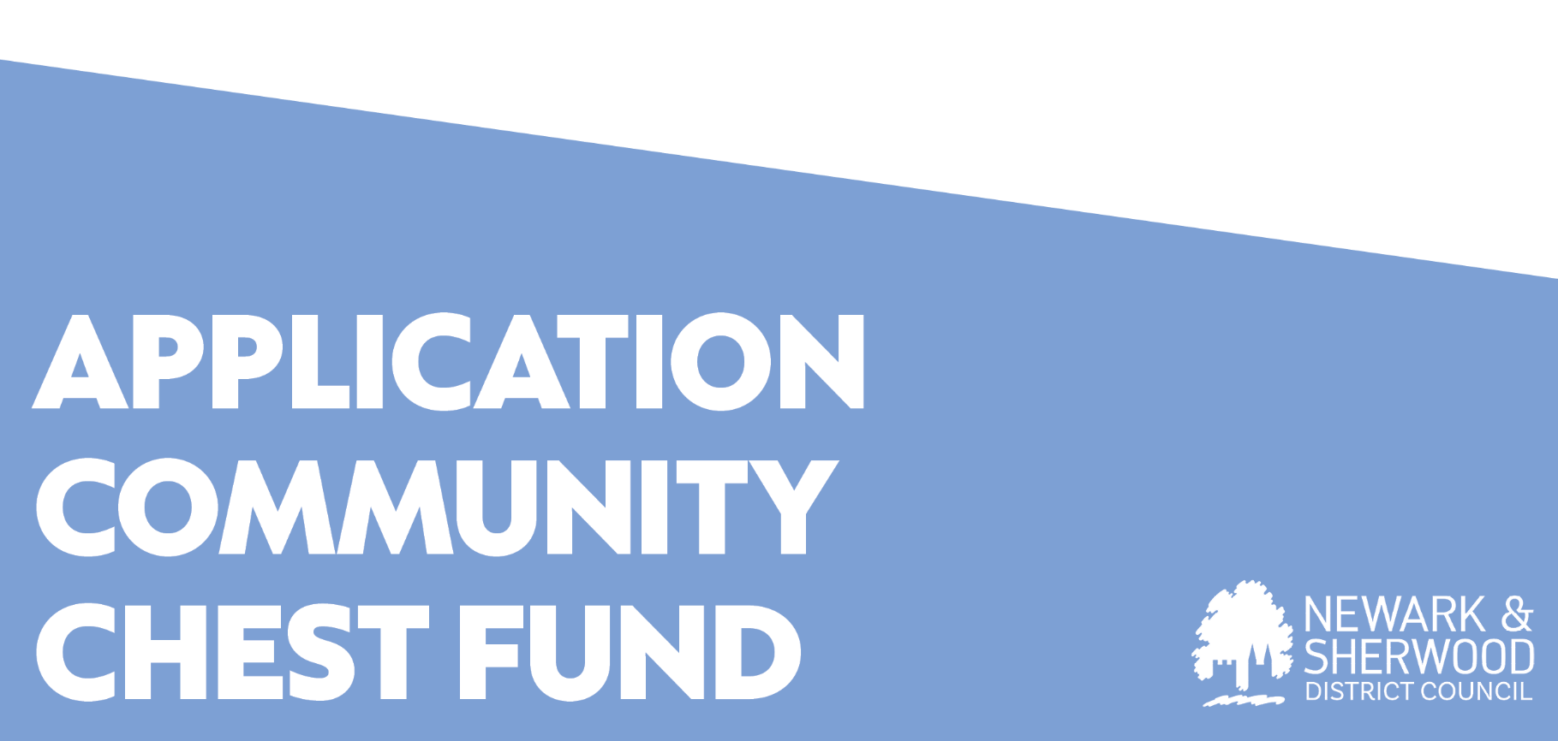

**Application Checklist - Check only those that apply to this application.**

**The application will:**

|  |  |
| --- | --- |
| Meet the criteria as noted in the Guidance Document |  |
| Benefit NSDC housing tenants and leaseholders. |  |
| Support a community development for NSDC tenants and leaseholders. |  |
| Support an empowerment project for NSDC tenants and leaseholders. |  |
| Support improving the amenities of social housing tenants or areas which social housing tenants use. |  |
| Support reducing anti-social behaviour around social housing. |  |
| Support the provision of safety and security measures for NSDC tenants. |  |
| Increase the wellbeing and mental health of NSDC tenants and leaseholders. |  |
| Support local sustainability projects particularly around waste management, litter, dog fouling and environmental issues. |  |
| Support the development of digital and financial inclusion projects with vulnerable tenant groups or individuals. |  |
| Support tenants into education, learning and volunteering opportunities. |  |
| Support the delivery of targeted health and wellbeing outcomes to vulnerable tenants or groups of tenants. |  |

|  |  |
| --- | --- |
| Name of group/organisation if applicable: | Click or tap here to enter text. |
| Number of NSDC tenants likely to benefit from the application | Click or tap here to enter text. |
| I/we agree to share at least two images of the project for NSDC promotional purposes. | Choose an item. |
| Have you received funding from NSDC within the previous 12 months? | Choose an item. |
| How much? | Click or tap here to enter text. |
| From which scheme? | Click or tap here to enter text. |

|  |  |
| --- | --- |
| **Grant amount requested.**  **(maximum £1000)** | £Click or tap here to enter text. |
| **Total cost of project.** | £Click or tap here to enter text. |
| **Other funding sources.** | £Click or tap here to enter text. |
| **Describe what the community chest funds will be used for:** | |
| Click or tap here to enter text. | |
| **What evidence do you have of the need for the project?**  **How have you consulted with NSDC tenants?** | |
| Click or tap here to enter text. | |
| **Outline how the project will achieve value for money:** | |
| Click or tap here to enter text. | |

|  |  |  |  |
| --- | --- | --- | --- |
| **BANK ACCOUNT DETAILS – External applicants only.**  (If your application is successful, we will pay the award through a BACS transfer) | | | |
| **Account Name** | Click or tap here to enter text. | | |
| **Account No.** | Click or tap here to enter text. | **Sort code** | Click or tap here to enter text. |

|  |  |  |
| --- | --- | --- |
| **DECLARATION** | | |
| I confirm I am authorised to sign this application (on behalf of the noted organisation if applicable). | | Click or tap here to enter text. |
| I, the undersigned, undertake that any grant awarded will be used solely for the purpose outlined in this application. I also understand that Newark & Sherwood District Council reserves the right to withhold the payment of the whole or any part of a grant or to require repayment of any grant if the information is subsequently discovered to be false. | | |
| **Organisation/Group (if applicable)** | Click or tap here to enter text. | |
| **Signed** |  | |
| **Print Name** | Click or tap here to enter text. | |
| **Date** | Click or tap to enter a date. | |
| **Return this signed Application Form with a signed copy of the Guidance Notes Declaration Page to** [**getinvolved@newark-sherwooddc.gov.uk**](mailto:getinvolved@newark-sherwooddc.gov.uk) | | |

|  |
| --- |
| **General Data Protection Regulation (GDPR) 2016 Privacy Notice**  The personal information you provide will only be used by Newark and Sherwood District Council, the data controller, in accordance with General Data Protection Regulation 2016/ Data Protection Act 2018 to process your application.  The basis for processing this information is to enable the council to undertake a public task.  Should your application be successful, some of your personal information may be included in a public register in accordance with our statutory responsibility under the Local Government Transparency Code.  Your personal data will be kept in accordance with the council’s retention policy and schedule. Details of which can be found on the council’s website:  In accordance with GDPR you have a right to:   * have a copy of the personal information that we hold about you * complain to the Information Commissioner if you feel that your information is not being handled appropriately   You may also have a right   * to erasure (also known as the right to be forgotten) * to stop processing   For further details about how your information may be used or about your rights under this legislation and any subsequent data protection legislation, please contact the council’s Information Governance Officer on 01636 655216 or via email on [freedom@newark-sherwooddc.gov.uk](mailto:freedom@newark-sherwooddc.gov.uk) |